Python – Programming
Python – Variables
A variable is a container in which we try to keep/store values. You don’t need to define the type of variables in python. It understands the type from the value it is assigned to.

print ("Saikat")
print (10 * 'Saikat')
print ('Saikat\'s "iphone"')
print (r"c:saikat\new_folder")
x=10;y=5
print(x+y)
name="youtube"
print (name)
print (name+ ' rocks') # concatenate strings
print (name[-2]) # reads the string from the ending


print (name[0:2]) #print 0,1 position of the string
print (name [1:4]) #print 1,2,3 position of the string
print (name [1:]) #print everything from the 1st position
print (name [:4]) #print everything upto 4th position
print ("String length: ", len(name)) #print the length of the string
#alternate way to print mytube
print ("my"+ name [3:])

Python – Collections
There are four collection data types in the Python programming language:
- List is a collection which is ordered and changeable. Allows duplicate members.
- Tuple is a collection which is ordered and unchangeable. Allows duplicate members.
- Set is a collection which is unordered and unindexed. No duplicate members.
- Dictionary is a collection which is unordered, changeable and indexed. No duplicate members.
When choosing a collection type, it is useful to understand the properties of that type. Choosing the right type for a particular data set could mean retention of meaning, and, it could mean an increase in efficiency or security.

nums= [25,12,36,89,95]
print (nums[0:2])
print (nums[-1], nums[-5])#prints the first and the last element
values=['saikat', 89, 69, 66, 'sengupta']
print(values[0:2])
mil= [nums, values] #Output: [[25, 12, 36, 89, 95], ['saikat', 89, 69, 66, 'sengupta']]
print (mil)
nums.insert(2,88) #Output: [25, 12, 88, 36, 89, 95]
print(nums)
nums.remove(25) # Output: [12, 88, 36, 89, 95]
print(nums)
#to remove element by index
nums.pop (3) #Output: [12, 88, 36, 95]
print(nums)
#simply use nums.pop to extract the last element. The last element will be removed from the list
print (nums.pop())
print(nums) #Output : [12, 88, 36]
#delete elements from a list
del nums [2:]
print (nums) #Output: [12, 88]
#to add multiple values in a list
nums.extend([44,56,77,21])
print(nums) #Output: [12, 88, 44, 56, 77, 21]
print("max value: ",max(nums))
print("min value: ",min(nums))
print("sum value: ",sum(nums))

List Comprehension
List comprehension is a way to populate a list in python which is different from the traditional method of populating a list using for loop. List comprehension is faster for transformation than traditional methods.
#below we will use list comprehension to create a list and compare against a simple list
str="human"
lst=[]
lst_comp=[]
lst_lmd=[]
# below list is populated without list comprehension
for i in str:
lst.append(i)
print(lst)
# below list is populated using list comprehension
lst_comp=[letter for letter in str]
print(lst_comp)
# list comprehension using lambda operation
lst_lmd=list(map(lambda x: x, str))
print(lst_lmd)

# applying conditions in a list comprehension
num_list= [x for x in range(20) if x%2==0 and (x%3!=0)]
print(num_list)
# applying nested if conditions in a list comprehension
num_lst= [x for x in range(20) if x%2==0 if x%5==0]
print(num_list)

# transpose of matrix using nested loops
transposed=[]
matrix=[[1,2,3,4], [4,5,6,7]]
print(len(matrix[0]))
for i in range(len(matrix[0])):
transposed_row=[]
for row in matrix:
print (row[i])
transposed_row.append(row[i])
transposed.append(transposed_row)
print(transposed)
# transpose using list comprehension
matrix= [[1,2,3,4], [4,5,6,7]]
transposed=[[row[i] for row in matrix] for i in range(4)]
print(transposed)

List Operation VS Tuple Operation
A list operation is slower than a tuple operation as tuples don’t allow changes in tuple elements i.e. they are fixed in numbers w.r.t. what’s declared during its creation.

Tuples
my_tuple1= (1,2,6,10,15,'A','B',"Str")
my_tuple2= (2,3,4,6,9)
my_tuple= (my_tuple1, my_tuple2)
print(my_tuple)
print("Length of tuple :", len(my_tuple))
#comparing two tuples
if (cmp(my_tuple1, my_tuple2!=0)):
print("Not the same")
else:
print("Both are same")
print("Accessing first tuple")
print(my_tuple[0:1])
print("Accessing second tuple")
print(my_tuple[1:2])
print("Accessing all the elements of the nested tuple")
itr=0
for i in my_tuple:
for k in range(len(i)):
print(my_tuple[itr][k])
itr=itr+1
print("Max and Min from mytuple1")
print("Max tuple element: "+ str(max(my_tuple2)))
print("Min tuple element: "+ str(min(my_tuple2)))

Set
set1= {'A','B','C','D', 1,2,2,2}
set2= {'A','D','F',3,2,6}
print("SET1 : ", set1)
print("SET2 : ", set2)
print("UNION" , set1.union(set2))
print("INTERSECTION" , set1.intersection(set2))
print("MINUS" , set1-set2)
print("SYMMETRIC DIFFERENCE" , set1 ^ set2)

Dictionary
Dictionary in Python is an unordered collection of data values, used to store data values like a map, which unlike other Data Types that hold only single value as an element, Dictionary holds key:value pair. Key value is provided in the dictionary to make it more optimized. Each key-value pair in a Dictionary is separated by a colon :, whereas each key is separated by a ‘comma’.
A Dictionary in Python works similar to the Dictionary in a real world. Keys of a Dictionary must be unique and of immutable data type such as Strings, Integers and tuples, but the key-values can be repeated and be of any type.
Note – Keys in a dictionary doesn’t allows Polymorphism.

#ASSIGINING A SIMPLE DICTIONARY
this_dict= {
"brand" : "Ford",
"model" : "Mustang",
"manufacture" : {
"day" : 18,
"month" : 10,
"year" : 1992
}
}
print(this_dict)
#change the year to current year inside nested dictionary
this_dict["manufacture"]["year"]=2019
print(this_dict)
#iterate through the dicttionary
for x in this_dict:
print("Key : ", str(x))
print("Value : ", this_dict[x])
#PRINTING ONLY VALUES
for x in this_dict.values():
print(x)
#ANOTHER WAY OF PRINTING ALL THE ITEMS
for x, y in this_dict.items():
print(x, y)
#DELETING A VALUE FROM DICTIONARY
#USE DEL TO REMOVE THE APPROPRIATE KEY IF REMOVING INSIDE THE NESTED DICTIONARY
del this_dict["manufacture"]["month"]
print(this_dict)
#USE POP TO REMOVE ELEMENT FROM THE ORIGINAL DICTIONARY NOT NESTED ONE
this_dict.pop("model")
print(this_dict)
#DELETE ANY KEY_VALUE PAIR ARBRITARILY
this_dict.popitem()
print(this_dict)

IF ELSE ELIF Statement
# to operate a car with below conditions
command=""
started=False
while True:
command= input("> ").lower()
if command== "start":
if started:
print("Car already started")
else:
started= True
print("Car Started")
elif command== "stop":
if not started:
print("Car is already stopped")
else:
started= False
print("Car Stopped")
elif command=="quit":
break;
elif command== "help":
print("""
start - to start the car
stop - to stop the car
quit - to quit
""")
else:
print("Command not recognized")

SWITCH Statement
A switch statement is a multiway branch statement that compares the value of the variable to the values specified in case statement. Python language doesn’t support switch statement. It uses dictionary mapping to implement switch statement.
#SWITCH STATEMENT IMPLEMENTATION - USING DICTIONARY
def SwitchExample (argument):
switcher= {
0:"This case is zero",
1:"This case is one",
2:"This case is two"
}
return switcher.get(argument, "nothing")
print(SwitchExample(2))

Python – Loops
Python has two primitive loop conditions: for loop and while loop
While Loop –
counter=1
while (counter <10):
print("Counter :" , counter)
counter+=1
else:
print("Counter reached 10")

For Loop –
Loops can be controlled using special statements like break, continue and pass
repeat= int(input("Enter a whole number"))
for i in range(repeat):
option= str(input("skip, pass, print or exit??"))
if (option=="print"):
print(i)
elif (option=="pass"):
pass
print("Passed")
elif (option=="skip"):
continue
print("Skipped")
elif (option=="exit"):
break
print("Goodbye")

Output
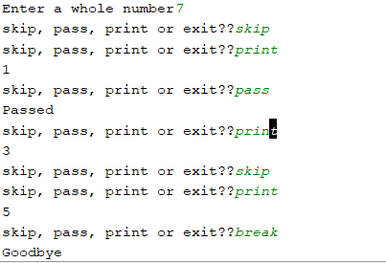
Difference between pass and continue: continue statement will skip the rest of the loop body and starts the next iteration while pass will pass certain conditions as per the context and move to next portion of the loop body. Here, pass prints Passed but continue doesn’t prints Skipped.

Break statement will exit the loop based on some particular condition.
presentPrices=[]
for i in range (5):
price= input("How much did this prsent cost in pounds?")
price= float(price)
presentPrices.append(price)
print("List as inserted :")
print(presentPrices)
#total up the list
print("Total : ", sum(presentPrices))
print("Highest price : ", max(presentPrices))
print("Lowest price : ", min(presentPrices))

Python – Functions
In python, functions are first class objects. This means that functions can be passed around and used as arguments, just like any other objects. Like any variable, you can pass them as an argument to another function or even return them as a return value.

Inner Function
def parent():
print("Printing from the parent() function")
def first_child():
print("Printing from the first_child() function")
def second_child():
print("Printing from the second_child() function")
second_child()
first_child()
parent()
Output
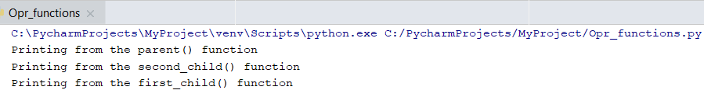
The inner functions are not defined until the parent function is called. They are locally scoped to parent(): they only exist inside the parent() function as local variables. Try calling first_child(). You should get an error. Whenever you call parent(), the inner functions first_child() and second_child() are also called. But because of their local scope, they aren’t available outside of the parent() function.

Returning function from function
def parent(num):
def first_child():
return "Hi I am first one"
def second_child():
return "Hi I am second one"
if num==1:
return first_child ()
elif num==2:
return second_child ()
else:
return "Invalid selection"
print(parent(2))

If you return the first_child or second_child without bracket then you will return the reference. In this case it will not print the output but it will print the reference ID. But here you are returning the function itself.

Python – Decorators
Decorators wrap a function, modifying its behavior.
Decorators act as a wrapper for your original function. Common use cases of decorators: 1. Logging 2. Timing

import time
def time_it (func):
def wrapper(*args, **kwargs):
start= time.time()
result= func(*args, **kwargs)
end= time.time()
print(func.__name__+" took "+ str((end-start)*1000) + " milliseconds.")
return result
return wrapper
@time_it #decorator
def calc_square(numbers):
result=[]
for number in numbers:
result.append(number * number)
return result
@time_it #decorator
def calc_cube(numbers):
result=[]
for number in numbers:
result.append(number * number * number)
return result
array= range(1, 1000)
out_square= calc_square(array)
out_cube= calc_cube(array)

The decorator is called before the execution of the function body. Inside the decorator body, the square or cube function is called with the array list from inside the wrapper function. Now once this individual functions are executed, the wrapper function returns the result of this function and at the same time prints the total time consumed for the function to operate and return the result.
Output
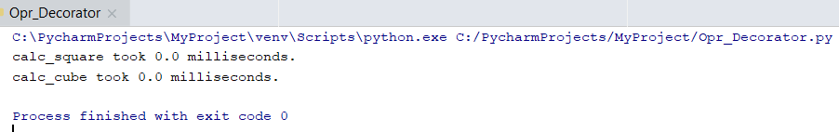

Python – Class
Class is the blueprint of an object. It provide a means of bundling data and functionality together. Creating a new class creates a new type of object, allowing new instances of that type to be made. Each class instance can have attributes attached to it for maintaining its state. Class instances can also have methods (defined by its class) for modifying its state.
self used inside the class is an inbuilt instance for the class. Same like this in java.
#Python Object Oriented Programming
class Employee:
def __init__(self, first, last, pay):
self.first= first
self.last= last
self.pay= pay
self.email= first + '.' + last + '@company.com'
def fullname(self):
return '{} {}'.format(self.first, self.last)
emp1= Employee ('Mick', 'Folly' , 50000)
emp2= Employee ('Test', 'User', 60000)
print(emp1) #prints the method instead of method value
print(emp1.email)
print(emp2.email)
print("{} {}".format(emp1.first, emp1.last))
print(emp2.fullname())
#below is how the object is called internally in emp2.fullname()
print(Employee.fullname(emp2))

Python – Main Method
In almost every programing language there is a special function which is executed automatically every time the program is run. This is the main function, or main() as it is usually denoted. It serves as the starting point for the execution of a program.
In python, it’s not necessary to define the main function every time you write a program. Python doesn’t have an entry point like C, C++ or Java. This is because the Python interpreter executes source file from the top unless a specific function has been defined.

Below if statement is allows you to create a main function which will be executed if your file is loaded as the "Main" module rather than as a library in another module.
#below print will work just like that
print ("Guru99")
#but to execute the main() method you need __name__="__main__" to call the main
def main():
print("Hello World")
if __name__=="__main__":
main()

Even if you just call main() after definition, it will work as internally python will create the condition
If __name__==”__main__”

Python – Class Variables
Class variables are variables which are shared among all instances of a class. While instance variable could be unique for each and every instances for ex: name, passport no, etc. but class variables are same across all instances.
Let’s say in the above example the company gives annual raises to all its employees’ i.e. same percentage raise for all. This is a good candidate for class variable.
#Python Object Oriented Programming
class Employee:
raise_amount=1.04 #class variable
tot_emps=0
def __init__(self, first, last, pay):
self.first= first
self.last= last
self.pay= pay
self.email= first + '.' + last + '@company.com'
#calculate the total no of employees each time a new instance is created
Employee.tot_emps +=1
def fullname(self):
return '{} {}'.format(self.first, self.last)
def apply_raise(self):
self.pay= int(self.pay * self.raise_amount)
print ("Total Employees =", Employee.tot_emps)
emp1= Employee ('Mick', 'Folly' , 50000)
emp2= Employee ('Test', 'User', 60000)
print(emp1) #prints the method instead of method value
print(emp1.email)
print(emp2.email)
print("{} {}".format(emp1.first, emp1.last))
print ("Total Employees =", Employee.tot_emps)
print(emp2.fullname())
#below is how the object is called internally in emp2.fullname()
print(Employee.fullname(emp2))
print("Payment of employee 1 before raise = ",emp1.pay)
emp1.apply_raise()
print("Payment of employee 1 after raise = ",emp1.pay)
#printing out the namespace of emp1 instnce
#we see emp1 has no raise_amt variable to it
print(emp1.__dict__)
#printing out the namespace for class Employee
#shows raise_amount is a class variable
print(Employee.__dict__)
#check the value of the class variable with below three ways
#all three prints 1.04
print(Employee.raise_amount)
print(emp1.raise_amount)
print(emp2.raise_amount)
#now lets use the below change
emp1.raise_amount= 1.05
print("raise_amount for emp1 has changed as below")
print(Employee.raise_amount)
print(emp1.raise_amount)
print(emp2.raise_amount)
print("Check the namespace for emp1 now")
#raise_amount field is created for the instance
#and referred from that instead of class variable
print(emp1.__dict__)

- When the instances like emp1 or emp2 is accessing the raise_amount variable, they don’t have that attribute themselves. They are accessing the attribute from the Class.
- You can create an instance of the class and use that instance to refer the class variable for calculation like here where raise_amount is used by emp1
- You can also create an instance specific variable like below:
emp1.raise_amount= 1.05
With this assignment the instance got the same variable only specific to the instance and not for the whole class.
- __dict__ is used to print the namespace for each object. This outputs the state for each variables/methods for any particular class or object.

Output
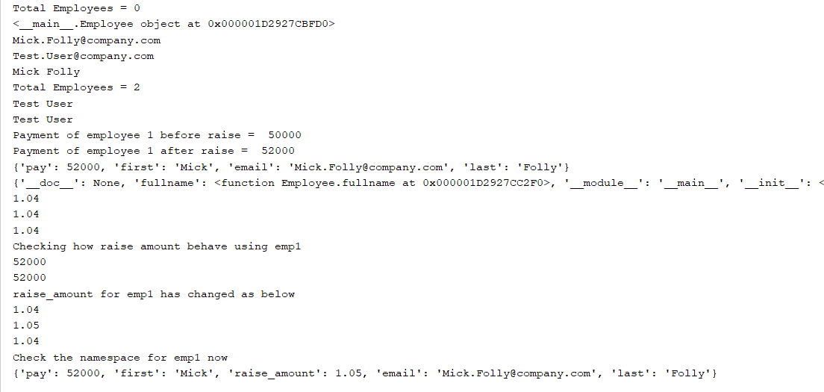

Python – Class Methods and Static Methods
The @classmethod decorator, is a built-in function decorator that is an expression that gets evaluated after your function is defined. The result of that evaluation shadows your function definition.
A class method receives the class as implicit first argument, just like an instance method receives the instance
- A class method is a method which is bound to the class and not the object of the class.
- They have the access to the state of the class as it takes a class parameter that points to the class and not the object instance.
- It can modify a class state that would apply across all the instances of the class. For example it can modify a class variable that will be applicable to all the instances.

class Employee:
raise_amount=1.04 #class variable
tot_emps=0
def __init__(self, first, last, pay):
self.first= first
self.last= last
self.pay= pay
self.email= first + '.' + last + '@company.com'
#calculate the total no of employees each time a new instance is created
Employee.tot_emps +=1
def fullname(self):
return '{} {}'.format(self.first, self.last)
def apply_raise(self):
self.pay= int(self.pay * self.raise_amount)
@classmethod
def set_raise_amount(cls, amount):
cls.raise_amount= amount
#below is a classic example of class method
#used as an alternative constructor
@classmethod
def from_string(cls, emp_str):
first, last, pay= emp_str.split('-')
return cls(first, last, pay) #returning class object

if __name__ == "__main__":
#use-case where employee input passed as a string with separator as '-'
emp1= 'John-Doe-70000'
emp2= 'Sam-Smith-80000'
# method to call split explicitly every time
first, last, sal = emp1.split('-')
new_emp1= Employee(first, last, sal)
print(new_emp1.email)
# method to call the class method to split and pass as object
new_emp2= Employee.from_string(emp2)
print(new_emp2.email)

While working with classes, regular methods automatically pass the instances as the first argument and we call that self and class method automatically pass the class as first argument and we call that cls, but static method don’t pass anything automatically.
Static method behave like regular functions and we include them inside class because they have some logical connection with the class. @staticmethod decorator is used to specify a method as static method.
- A static method is also a method which is bound to the class and not the object of the class.
- A static method can’t access or modify class state.
- It is present in a class because it makes sense for the method to be present in class.
import datetime
class Employee:
@classmethod
def from_string(cls, emp_str):
first, last, pay= emp_str.split('-')
return cls(first, last, pay)
@staticmethod
def is_workday(day):
if day.weekday()== 5 or day.weekday()== 6:
return False
return True

if __name__ == "__main__":
my_date= datetime.date(2016, 7, 10)
print(Employee.is_workday(my_date))

Class Method VS Static Method
- A class method takes cls as first parameter while a static method needs no specific parameters.
- A class method can access or modify class state while a static method can’t access or modify it.
- In general, static methods know nothing about class state. They are utility type methods that take some parameters and work upon those parameters. On the other hand class methods must have class as parameter.
- We use @classmethod decorator in python to create a class method and we use @staticmethod decorator to create a static method in python.

When to use what?
- We generally use class method to create factory methods. Factory methods return class object (similar to a constructor) for different use cases.
- We generally use static methods to create utility functions.

Python – Inheritance
Inheritance is the capability of one class to derive or inherit the properties from some another class. The benefits of inheritance are:
- It represents real-world relationships well.
- It provides reusability of a code. We don’t have to write the same code again and again. Also, it allows us to add more features to a class without modifying it.
- It is transitive in nature, which means that if class B inherits from another class A, then all the subclasses of B would automatically inherit from class A.

class Employee:
raise_amount=1.04 #class variable
tot_emps=0
def __init__(self, first, last, pay):
self.first= first
self.last= last
self.pay= pay
self.email= first + '.' + last + '@company.com'
#calculate the total no of employees each time a new instance is created
Employee.tot_emps +=1
def fullname(self):
return '{} {}'.format(self.first, self.last)
def apply_raise(self):
self.pay= int(self.pay * self.raise_amount)
class Developer(Employee):
raise_amount = 1.10
def __init__(self, first, last, pay, prog_lang=None):
super().__init__(first, last, pay)
self.prog_lang= prog_lang
class Manager(Employee):
def __init__(self, first, last, pay, employees= None):
super().__init__(first, last, pay)
if employees is None:
self.employees= []
else:
self.employees=employees
def employee_add(self, emp):
if emp not in self.employees:
self.employees.append(emp)
def employee_remove(self, emp):
if emp in self.employees:
self.employees.remove(emp)
def print_employees(self):
for emp in self.employees:
print("-->", emp.fullname())
if __name__=="__main__":
dev1= Developer('John','Dofey',60000)
dev2= Developer('Kim','Little',40000)
print(dev1.email)
print(dev2.email)
#print(help(Developer)) to get details of what inherited by the subclass
print(dev1.pay)
#below apply raise function will refer to the raise amount provided in the sub class
dev1.apply_raise()
print(dev1.pay)
#for developers suppose we want to pass their main programming language as an attribute
#in such cases, we will append the constructor inside developer class
dev3 = Developer('Kim', 'Little', 40000, 'Python')
print(dev3.prog_lang)
#creating a new manager
mgr1= Manager('John','Kussac', 90000, [dev1])
print(mgr1.email)
print("Print employees for manager after initial assignment")
mgr1.print_employees()
print("Print employees for manager after adding employee")
mgr1.employee_add(dev3)
mgr1.print_employees()
print("Print employees for manager after removing employee")
mgr1.employee_remove(dev1)
mgr1.print_employees()
#few more functionalities on inheritance and sub classes
print(isinstance(mgr1, Manager)) # True
print(isinstance(mgr1, Employee)) # True
print(isinstance(mgr1, Developer)) # False
print(issubclass(Developer, Employee)) # True
print(issubclass(Developer, Manager)) # False

Python – Special & Dunder Methods
Dunder methods are all such special methods whose names begins and ends with double underscore. For ex: __name__, __str__, __repr__
str
s = 'Hello, Geeks.'
print str(s)
print str(2.0/11.0)
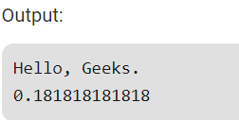

repr
s = 'Hello, Geeks.'
print repr(s)
print repr(2.0/11.0)
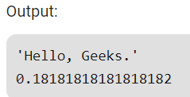
We can see if we print string using repr() function then it prints with a pair of quotes and if we calculate a value we get more precise value than str() function.
Following are differences:
- str() is used for creating output for end user while repr() is mainly used for debugging and development. repr’s goal is to be unambiguous and str’s is to be readable. For example, if we suspect a float has a small rounding error, repr will show us while str may not.
- repr() compute the “official” string representation of an object (a representation that has all information about the abject) and str() is used to compute the “informal” string representation of an object (a representation that is useful for printing the object).
- The print statement and str() built-in function uses __str__ to display the string representation of the object while the repr() built-in function uses __repr__ to display the object.

class Employee:
raise_amount=1.04 #class variable
tot_emps=0
def __init__(self, first, last, pay):
self.first= first
self.last= last
self.pay= pay
self.email= first + '.' + last + '@company.com'
#calculate the total no of employees each time a new instance is created
Employee.tot_emps +=1
def fullname(self):
return '{} {}'.format(self.first, self.last)
def apply_raise(self):
self.pay= int(self.pay * self.raise_amount)
def __repr__(self):
return "Employee('{}','{}','{}')".format(self.first, self.last, self.pay)
def __str__(self):
return '{} - {}'.format(self.fullname(), self.email)
if __name__=="__main__":
emp1= Employee("John","Boyle",65000)
print("By default __str__ is called")
print(emp1)
print("Call __str__ and __repr__ directly/explicitly")
print(emp1.__repr__())
print(emp1.__str__())
print("Another way of calling special methods")
print(repr(emp1))
print(str(emp1))

Output
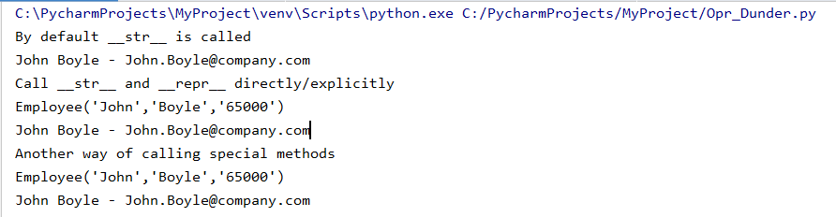

In real world, when we are add two numbers, in backend dunder method __add__ is called. For ex:
a=6
b=7
print(a+b) # output : 13
print(a.__add__(b)) # output : 13
str1= "Saikat"
str2= "Sengupta"
print(str1 + str2) # output : SaikatSengupta
print(str1.__add__(str2)) # output : SaikatSengupta

You can also implement this add function for a specific class by overriding it to add the salaries of two employee instances passed with it as below.

class Employee:
raise_amount=1.04 #class variable
tot_emps=0
def __init__(self, first, last, pay):
self.first= first
self.last= last
self.pay= pay
self.email= first + '.' + last + '@company.com'
#calculate the total no of employees each time a new instance is created
Employee.tot_emps +=1
def fullname(self):
return '{} {}'.format(self.first, self.last)
def apply_raise(self):
self.pay= int(self.pay * self.raise_amount)
def __add__(self, other):
return self.pay + other.pay
def __len__(self):
return len(self.fullname())

if __name__=="__main__":
emp1= Employee("John","Boyle",65000)
emp2 = Employee("Sam", "Smith", 35000)
#below add and len will call the overloaded methods inside the class
print(emp1 + emp2)
print(len(emp2))

Property Decorators – Getters, Setters and Deleters
In Python, getters and setters are not the same as those in other object-oriented programming languages. Basically, the main purpose of using getters and setters in object-oriented programs is to ensure data encapsulation. Private variables in python are not actually hidden fields like in other object oriented languages. Getters and Setters in python are often used when:
- We use getters & setters to add validation logic around getting and setting a value.
- To avoid direct access of a class field i.e. private variables cannot be accessed directly or modified by external user.

Python @property is one of the built-in decorators. The main purpose of any decorator is to change your class methods or attributes in such a way so that the user of your class no need to make any change in their code. For Example
class Employee:
raise_amount=1.04 #class variable
tot_emps=0
def __init__(self, first, last):
self.first= first
self.last= last
#self.email= first + '.' + last + '@company.com'
@property
def email(self):
return '{}.{}@email.com'.format(self.first, self.last)
@property
def fullname(self):
return '{} {}'.format(self.first, self.last)
@fullname.setter
def fullname(self, name):
first, last= name.split(" ")
self.first= first
self.last= last
@fullname.deleter
def fullname(self):
print("Delete Name!")
self.first = None
self.last = None
if __name__=="__main__":
emp1= Employee('John', 'Smith')
emp1.first='Black'
print(emp1.email)
emp1.fullname="Suresh Roy"
print(emp1.fullname)
#to delete the full name for an instance
del emp1.fullname
print(emp1.fullname)

Output
